Distance & Similarity
In clustering, algorithms need ways to measure how similar or different data points are. Distance and similarity metrics do exactly that. They help determine which points belong together in the same group. Here are the main ones.
Euclidean Distance
Euclidean distance is the most common metric. It measures the straight-line distance between two points in n-dimensional space.
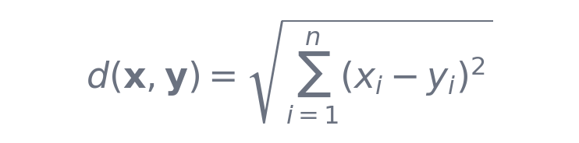
For each feature i, subtract the value in y from the value in x. Square that difference to remove negatives and give more weight to bigger gaps. Add up all the squared differences. Finally, take the square root. This brings the result back to the same units as the original data. It is the multi-dimensional version of the Pythagorean theorem.
Key properties
- Sensitive to feature scale
- Sensitive to outliers
- Assumes spherical clusters
Use it when:
- Data is continuous + properly scaled
- Clusters are spherical (K-Means assumption)
example: Consider points A = (2, 3) and B = (5, 7). The differences are 3 and 4. Squared: 9 and 16. Sum is 25. The square root of 25 is 5. So the Euclidean distance is 5.0.
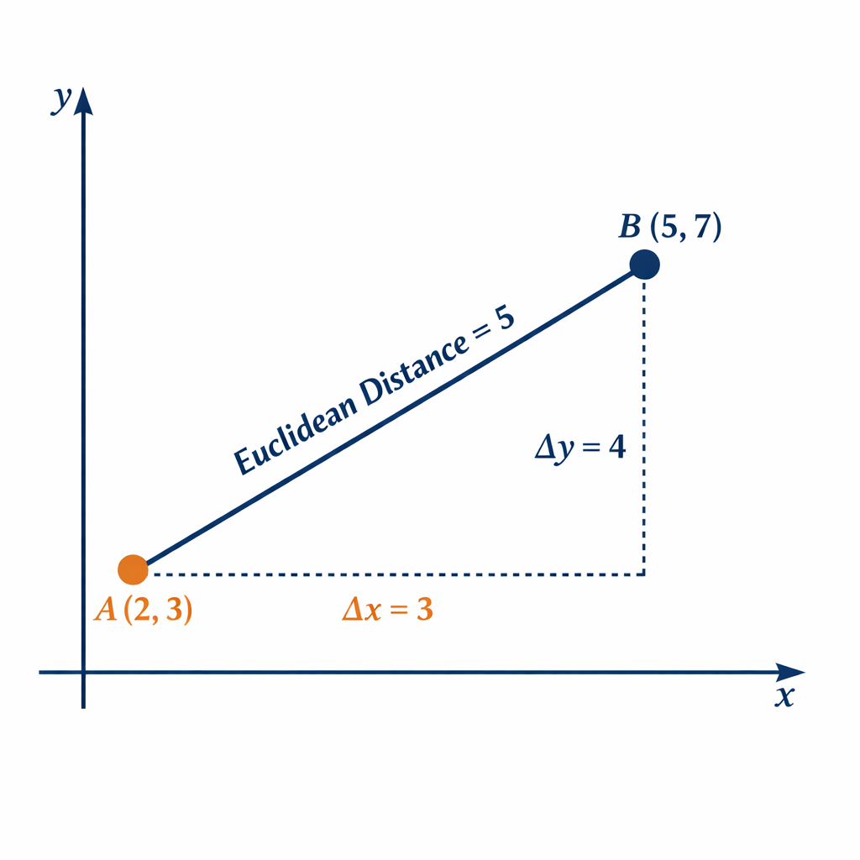
Manhattan Distance
Manhattan distance, also known as L1 distance or city-block distance, adds up the absolute differences along each dimension.

You take the absolute value of the difference in every feature and simply add them together. No squaring or roots are involved.
Using the same points A = (2, 3) and B = (5, 7): absolute differences 3 and 4. Sum is 7.
This metric is less sensitive to outliers than Euclidean distance and works well for high-dimensional or grid-like data. In real life, think of the distance a taxi drives in a city laid out in blocks; you can only go north-south or east-west.
Key properties
- Less sensitive to outliers
- Works better in high-dimensional spaces
- Produces diamond-shaped clusters
Use it when:
- Data has noise or outliers
- Features are independent
- Grid-like structure (images, discrete movement)

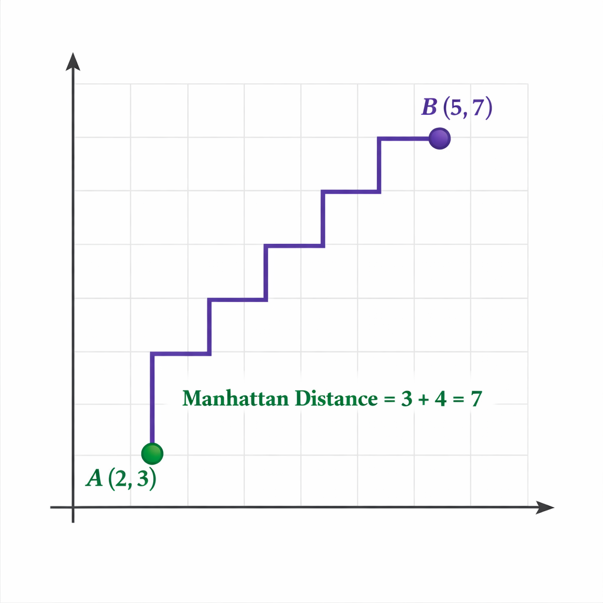
Minkowski Distance
Minkowski distance is a flexible generalization that covers both Euclidean and Manhattan distances.
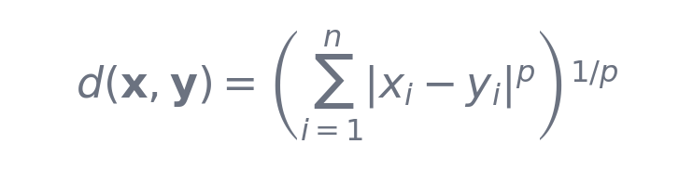
The parameter p controls the type. For p = 1 it reduces to the Manhattan distance. For p = 2 it becomes Euclidean. Higher values of p put more emphasis on larger differences between features.
p =1 → Manhattan
p=2→ Euclidean
p→∞ → Chebyshev (max difference)
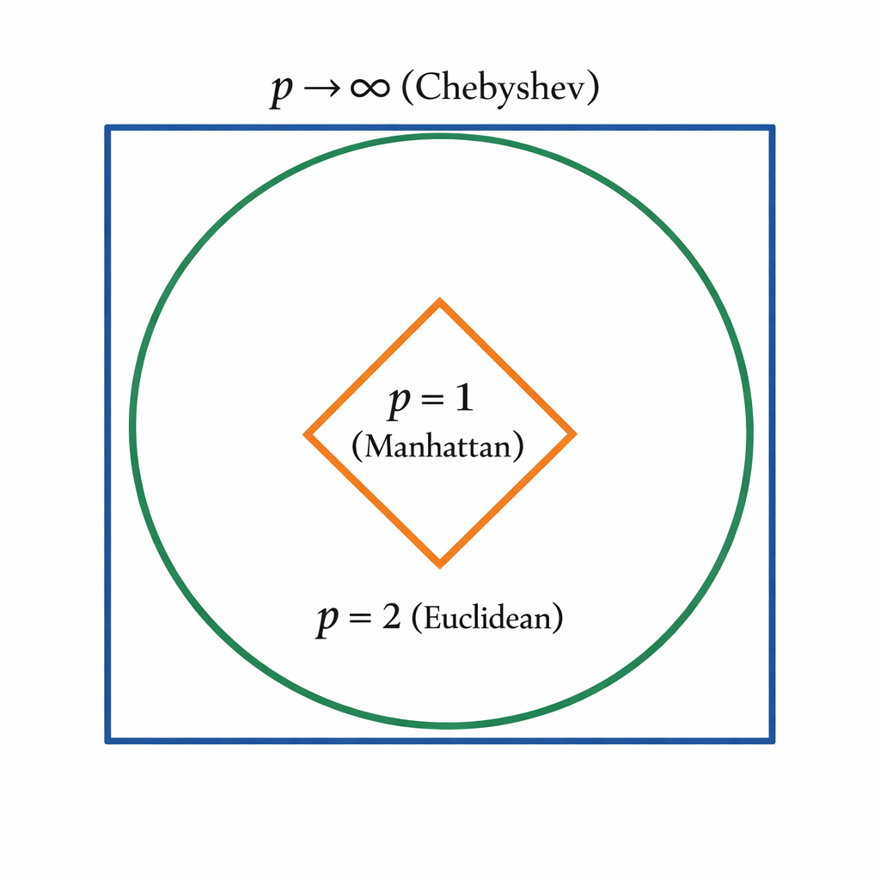
You can tune ‘p’ based on your data to get the behavior that works best for your clustering task.
Key properties
- Flexible metric
- Rarely tuned beyond p=1 or p = 2 in practice
NOTE : Euclidean distance forms circular (spherical) clusters, while Manhattan distance forms diamond-shaped clusters, directly influencing cluster boundaries.
Cosine Similarity
Cosine similarity measures the angle between two vectors instead of their magnitude difference. It is particularly useful when the length of the vectors varies but their direction is what matters.
The formula for cosine similarity is:

The dot product x⋅y is the sum of the products of corresponding features: sum(x_i * y_i). The norms ||x|| and ||y|| are the Euclidean lengths of each vector. The result ranges from -1 to 1. A value close to 1 means the vectors point in almost the same direction.
For our points (2,3) and (5,7), the cosine similarity is approximately 0.9995 very high, as they point almost the same way. In clustering, people often convert this to distance using 1 minus the similarity.
Interpretation
- Value range: [−1,1][-1, 1][−1,1]
- Close to 1 → vectors point in similar direction
- Ignores magnitude differences
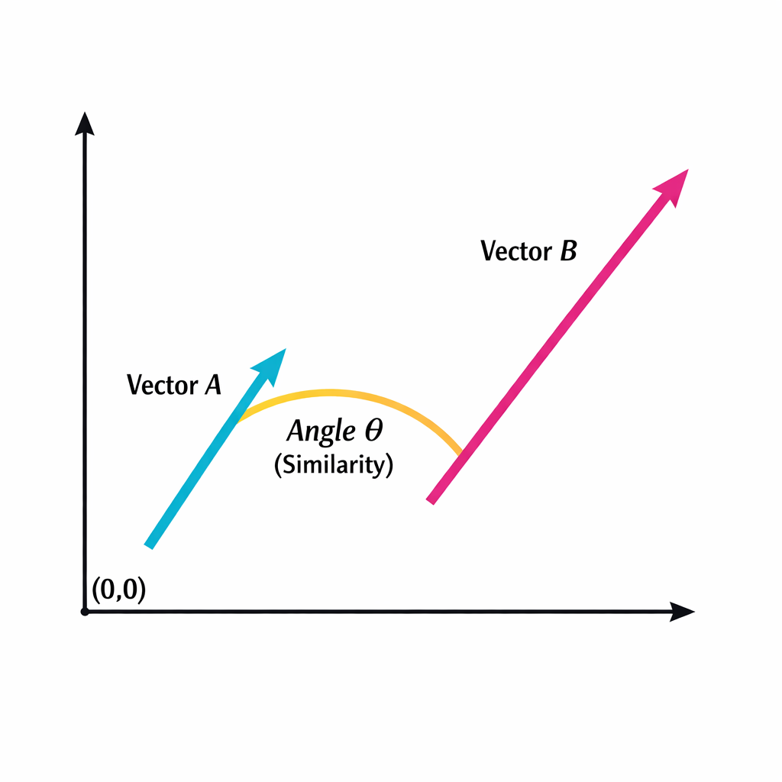
Example:
comparing two documents or customer profiles. Two articles can be long or short but cover the same topic. Cosine similarity ignores length and focuses on the overlap in content.
Jaccard Similarity
While Cosine Similarity is great for text and magnitudes, Jaccard Similarity is used specifically when your data is binary (yes/no, 1/0) or consists of sets (like a shopping cart of items).
It measures the overlap between two sets. The formula divides the number of shared items (the intersection) by the total number of unique items across both sets (the union). Crucially, it completely ignores features where both values are 0 (e.g., if two customers both didn't buy a product, it doesn't count as a similarity).
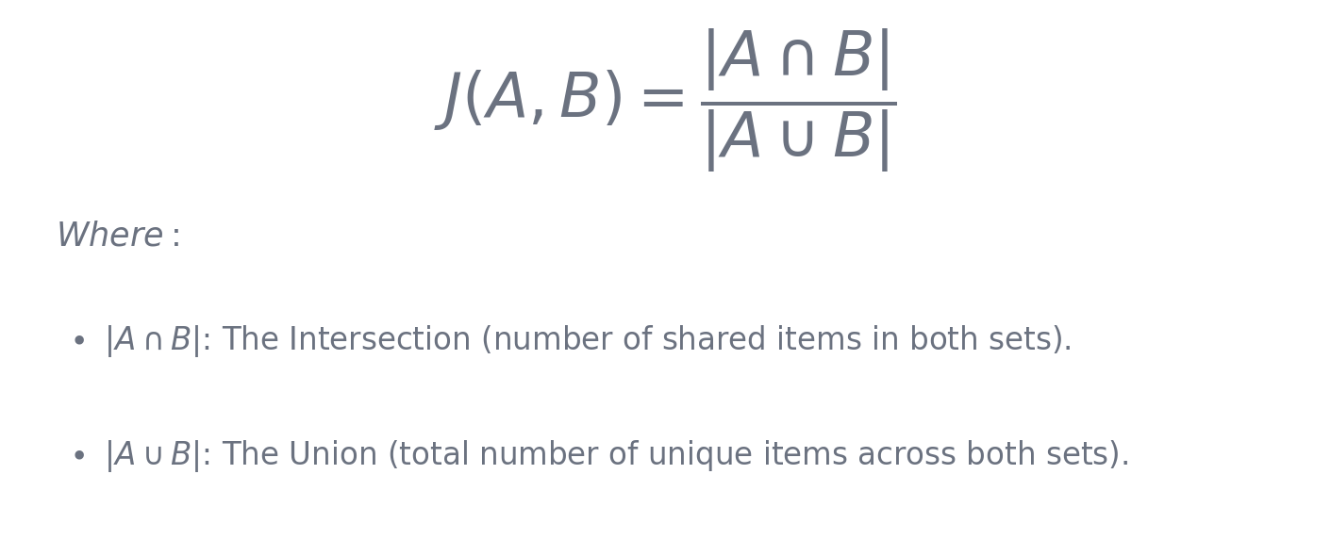
Working: It measures the overlap between two sets. The formula divides the number of shared items by the total number of unique items. Crucially, it completely ignores features where both values are 0 (e.g., if two customers both didn't buy a product, it doesn't count as a similarity).
Use it when:
- Comparing shopping carts, user clickstreams, or one-hot encoded categorical data.
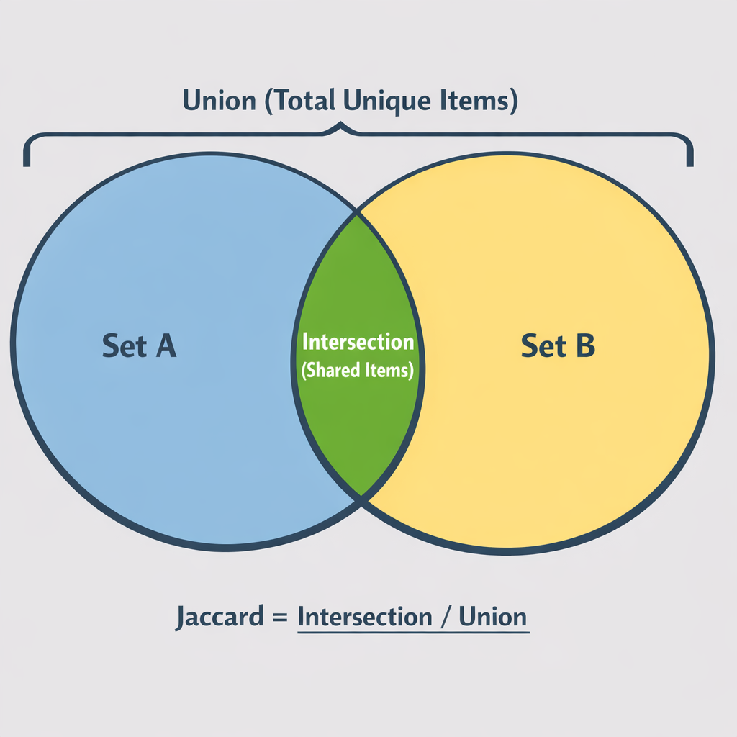

Mahalanobis Distance
Euclidean distance assumes that your data clusters are perfectly spherical and that all features are independent. However, in the real world, features are often correlated (e.g., as height increases, weight usually increases). This creates stretched, oval-shaped distributions.
Working:Mahalanobis distance solves correlation by factoring in the variance and covariance of the dataset. It effectively "unstretches" the data before calculating the distance. If you use Euclidean distance on stretched data, points that belong to the same cluster might seem far apart. Mahalanobis distance correctly calculates their distance relative to the shape of the data distribution.
Use it when:
- Your features are highly correlated and you are looking for multivariate outliers.
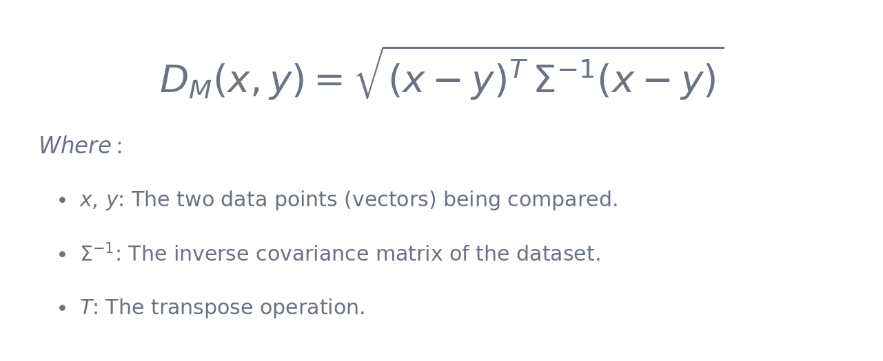
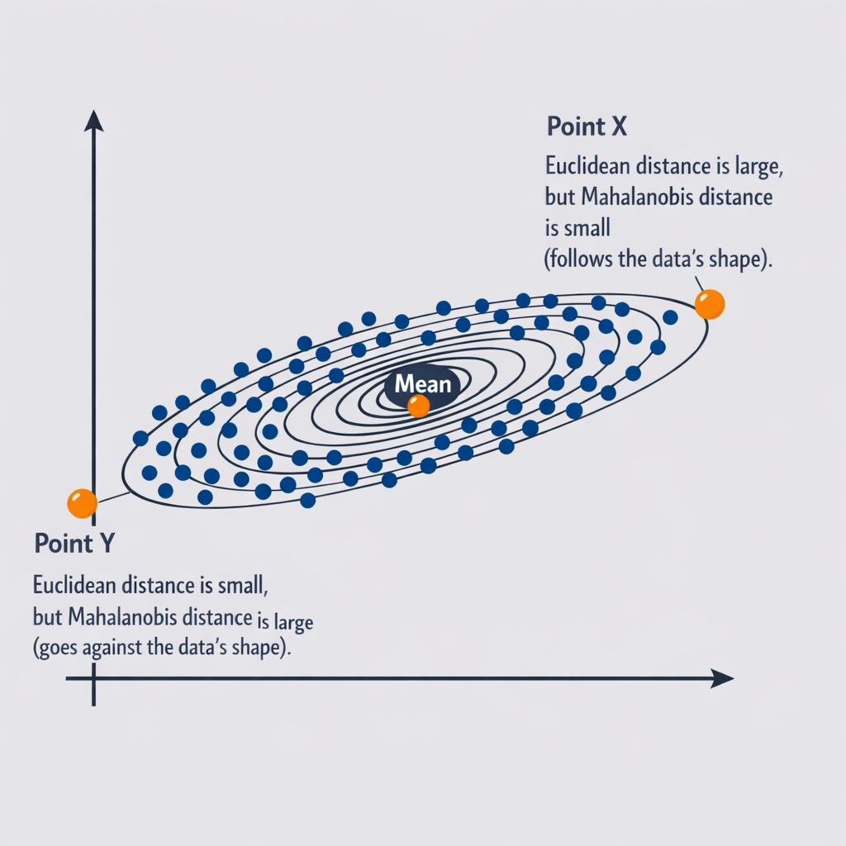
QUIZ
1. Which distance metric is also known as the “straight-line” or “as-the-crow-flies” distance?
a) Manhattan distance
b) Euclidean distance
c) Cosine distance
d) Chebyshev distance

2. What is the range of values for cosine similarity (not distance)?
a) 0 to 1
b) -1 to 1
c) 0 to ∞
d) -∞ to ∞

3. When p = 1 in the Minkowski distance formula, it becomes:
a) Euclidean distance
b) Manhattan distance
c) Chebyshev distance
d) Cosine distance

4. Why does Euclidean distance often give poor results when features are on very different scales (e.g., age in years vs income in rupees)?
a) It ignores magnitude completely
b) Large-scale features dominate due to squaring
c) It becomes non-metric
d) It only works in 2D space

5. In which scenario is Manhattan distance usually more robust than Euclidean distance?
a) When clusters are perfectly spherical
b) When the data contains outliers in individual dimensions
c) When all features are already normalized to unit length
d) When working with text embeddings

6. You compute cosine similarity between two vectors and get ≈ 0.998. What does this tell you?
a) The vectors are very far apart in absolute distance
b) The vectors point in almost exactly the same direction
c) The Euclidean distance between them is very small
d) The vectors are almost orthogonal

7. Which of the following is not a valid property of Minkowski distance for p ≥ 1?
a) It satisfies the triangle inequality
b) It is zero if and only if the two points are identical
c) It is symmetric
d) It always ignores vector magnitude like cosine does

8. Consider two points A = (1, 100) and B = (2, 200). Their Euclidean distance is ≈ 100.04. Their cosine similarity is very close to 1. Which statement best explains this large difference in behavior?
a) Euclidean is scale-invariant, cosine is not
b) Cosine is direction-based and ignores scaling, Euclidean is magnitude-sensitive
c) Manhattan would give exactly the same result as cosine here
d) This only happens when p > 2 in Minkowski

9. In very high-dimensional space (hundreds or thousands of dimensions), which phenomenon makes Euclidean distance less reliable compared to cosine similarity for tasks like text clustering?
a) The blessing of dimensionality
b) Distance concentration (most points become almost equidistant)
c) Loss of triangle inequality
d) Increased sensitivity to p in Minkowski

10. You are clustering user movie rating profiles (1–5 stars) where some users rate 10 movies and others rate 200. Many ratings are missing (treated as 0 or skipped). Which combination of representation + distance metric is most commonly recommended in literature and practice?
a) Raw ratings + Euclidean distance
b) Mean-centered ratings + Manhattan distance
c) tf-idf-like normalization or row normalization + Cosine similarity
d) Binary (watched / not watched) + Chebyshev distance

